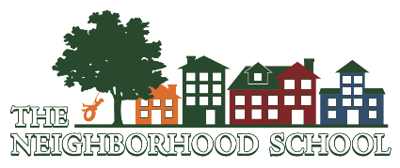 DFS Licensing Rules & Regulations
511 W 19th St.
Cheyenne, WY 82001
307-632-3339

Employees are asked to acknowledge they have received (through the website), read and understand the contents of the Department of Family Services Wyoming Child Care Licensing Rules.

Employee’s Name (print)_______________________________________________________________________

Employee’s Signature__________________________________________________________________________

Date_______________________

